Industrial Electrical Actuators

Continuous actuators allow a system to position or adjust outputs over a wide range of values. Even in their simplest form, continuous actuators tend to be mechanically complex devices. For example, a linear slide system might be composed of a motor with an electronic controller driving a mechanical slide with a ball screw. The cost for such actuators can easily be higher than for the control system itself. These actuators also require sophisticated control techniques that will be discussed in later chapters. In general, when there is a choice, it is better to use discrete actuators to reduce costs and complexity. Electrical actuators include:

* Electric Motors
  + - DC servomotors
    - AC motors
    - Stepper motors
* Solenoids

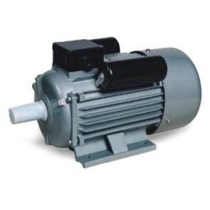 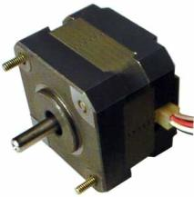 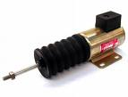

Electrical Actuators

Where a pneumatic supply is not available or desirable it is possible to use an electric actuator to control the valve. Electric actuators use an electric motor with voltage requirements in the following range: 230Vac, 110Vac, 24Vac and 24Vdc. There are two types of electrical actuator; VMD (Valve Motor Drive) and Modulating.

[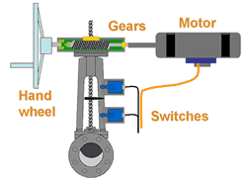](http://www.valve-world.net/actuation/ShowPage.aspx?pageID=557#fig1)

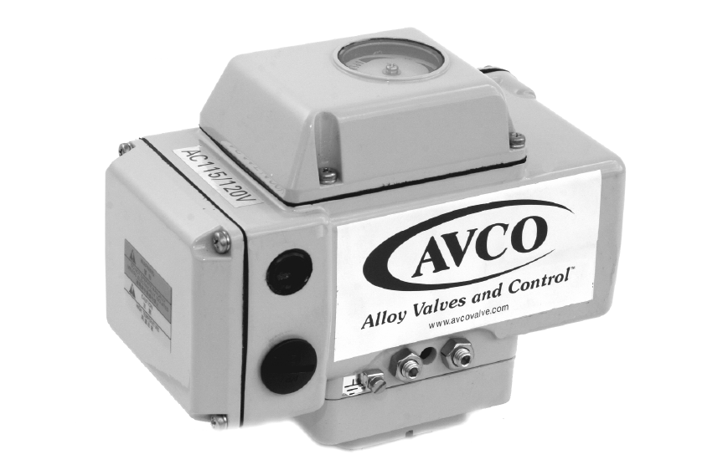

**VMD (Valve Motor Drive) Actuator**

This basic version of the electric actuator has three states:

1. Driving the valve open.
2. Driving the valve closed.
3. No movement.

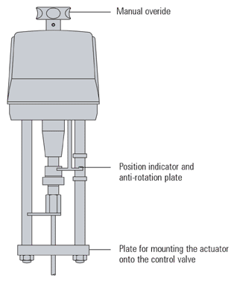

Fig. 6.6.19 Typical Electric Valve Actuator

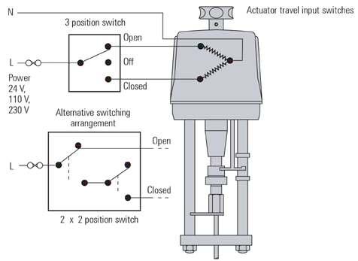

Fig. 6.6.20 Valve Motor Drive Actuator System

Figure 6.6.20 shows the VMD system where the forward and reverse travel of the actuator is controlled directly from any external 3-position or two 2-position switch units. The switches are rated at the actuator voltage and may be replaced by suitable relays.

Limiting devices are fitted within the VMD actuators to protect the motors from over-travel damage. These devices are based on either the maximum motor torque or physical position limit switches. Both devices stop the motor driving by interrupting the motor power supply.

* Position limit switches have the advantage that they can be adjusted to limit valve strokes in oversized valves.
* Torque switches have the advantage of giving a defined closing force on the valve seat, protecting the actuator in the case of valve stem seizure.
* If only position limit switches are used, they may be combined with a spring-loaded coupling to ensure tight valve shut-off.

A VMD actuator may be used for on/off actuation or for modulating control. The controller positions the valve by driving the valve open or closed for a certain time, to ensure that it reaches the desired position. Valve position feedback may be used with some controllers.

**Modulating Actuator/Control**

If an actuator is required to control a level, flow or pressure in a system, then it may be required to move frequently. Modulating or positioning control can be achieved using the same 4-20 milliamps signal. However, the signal would change as frequently as the process required. If very high rates of modulation are required then special modulating control valve actuators are needed that can accommodate the frequent starts required for such duty.

[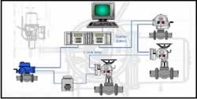](http://www.valve-world.net/actuation/ShowPage.aspx?pageID=557#fig5)

Figure 5: Digital Communication Systems

Where there are many actuators on a process, the capital cost of installation can be reduced by utilizing digital communication over a communicating loop that passes from one actuator to another. A digital communication loop can deliver commands and collect actuator status rapidly and cost effectively. There are many types of digital communication such as Foundation Fieldbus, Profibus, DeviceNet, HART, as well as proprietary communication systems custom designed for valve actuator use such as Pakscan. Digital communication systems have many advantages over and above the saving in capital cost. They are able to collect a lot of data about the condition of the valve, and as such can be used for predictive maintenance programs.

In order to position the control valve in response to the system requirements a modulating actuator can be used. These units may have higher rated motors (typically 1 200 starts/hour) and may have built-in electronics. A positioning circuit may be included in the modulating actuator, which accepts an analogue control signal (typically 0-10V or 4-20mA). The actuator then interprets this control signal, as the valve position between the limit switches.  
To achieve this, the actuator has a position sensor (usually a potentiometer), which feeds the actual valve position back to the positioning circuit. In this way the actuator can be positioned along its stroke in proportion to the control signal. A schematic of the modulating actuator is shown in Figure 6.6.21.

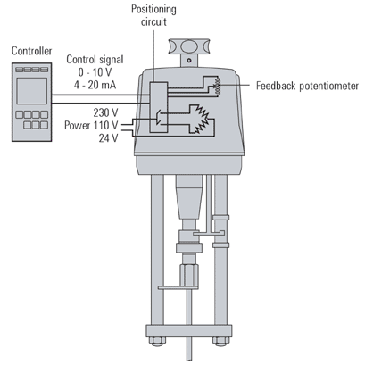

Fig. 6.6.21 Integral positioning circuit for Modulating Electric Actuators

Pneumatic actuators have an inherent fail-safe feature; should the air supply or control signal fail the valve will close. To provide this function in electric actuators, 'spring reserve' versions are available which will open or close the valve on power or control signal failure. Alternatively, fail-safe can be provided with battery power. Electric actuators offer specified forces, which may be limited on spring reserve versions. The manufacturer's charts should always be consulted during selection.

Electric Motors

An electric motor is composed of a rotating center, called the rotor, and a stationary outside, called the stator. These motors use the attraction and repulsion of magnetic fields to induce forces, and hence motion. Typical electric motors use at least one electromagnetic coil, and sometimes permanent magnets to set up opposing fields. When a voltage is applied to these coils the result is a torque and rotation of an output shaft. There are a variety of motor configuration the yields motors suitable for different applications. Most notably, as the voltages supplied to the motors will vary the speeds and torques that they will provide. Motor categories include:

* **AC motors** - rotate with relatively constant speeds proportional to the frequency of the supply power.
  + **Induction motors** - squirrel cage, wound rotor - inexpensive, efficient.
  + **Synchronous** - fixed speed, efficient
* **DC motors** - have large torque and speed ranges.
  + Permanent magnet - variable speed
  + Wound rotor and stator - series, shunt and compound (universal)
* **Hybrid** 
  + Brushless permanent magnet
  + Stepper motors

**Stepper Motors**

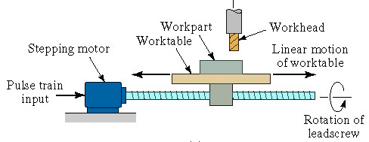

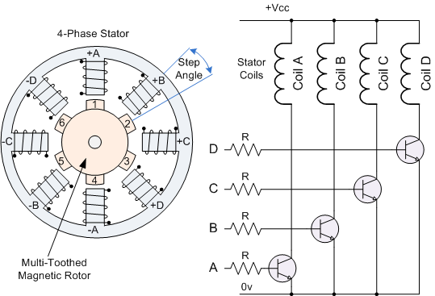

**Step angle** is given by: 

Where *ns* is the number of steps for the stepper motor (integer)

**Total angle** through which the motor rotates (*Am*) is given by: 

**Angular velocity** is given by: 

Where *fp* = pulse frequency

**Speed of rotation** is given by: 

**Example**

A stepper motor has a step angle = 3.6°.

(1) How many pulses are required for the motor to rotate through ten complete revolutions?

(2) What pulse frequency is required for the motor to rotate at a speed of 100rev/min?

**Solution**



(1) 3.6° = 360 / *ns*; 3.6° (*ns*) = 360; *ns* = 360 / 3.6 = 100 step angles



(2) Ten complete revolutions: 10(360°) = 3600° = *Am* Therefore *np* = 3600 / 3.6 = 1000 pulses



Where *N* = 100 rev/min:

100 = 60 *fp* / 100

10,000 = 60 *fp*

*fp* = 10,000 / 60 = 166.667 = 167 Hz

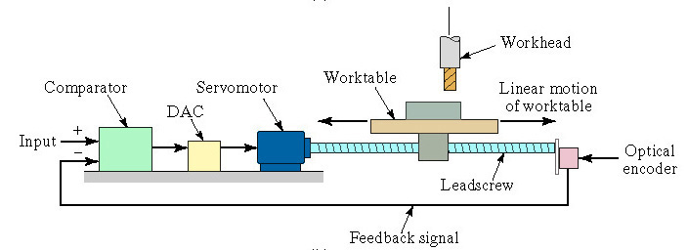

**Servo-Motor Configuration**

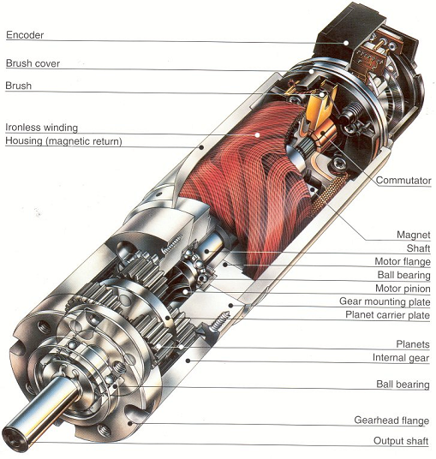

**Motor Drives**

Contactors are used to switch motor power on/off. Drives can be used to vary motor speeds electrically. This can also be done with mechanical or hydraulic machines.

* Popular drive categories
  + **Variable Frequency Drives** (VFD) - vary the frequency of the power delivered to the motor to vary speed.
  + **DC motor controllers** - variable voltage or current to vary the motor speed
  + **Eddy Current Clutches for AC motors** - low efficiency, uses a moving iron drum and windings
  + **Wound rotor AC motor controllers** - low efficiency, uses variable resistors to adjust the winding currents

A control system is required when a motor is used for an application that requires continuous position or velocity. A typical controller is shown in Figure 15.1. In any controlled system a command generator is required to specify a desired position. The controller will compare the feedback from the encoder to the desired position or velocity to determine the system error. The controller will then generate an output, based on the system error. The output is then passed through a power amplifier, which in turn drives the motor. The encoder is connected directly to the motor shaft to provide feedback of position.

