Introduction to Process Control Actuators

Actuators are the final elements in a control system. They receive a low power command signal and energy input to amplify the command signal as appropriate to produce the required output. Applications range from simple low power switches to high power hydraulic devices operating flaps and control surfaces on aircraft; valves, car steering, process plant automation, etc.

Process Control Laws!

First Law: The best control system is the simplest one that will do the job.
Second Law: You must understand the process before you can control it.
Third Law: The control is never possible if the mathematical model can not be developed.

Process Control System

A basic process control system would normally consist of the following components:
- Actuators
- Control Valves
- Sensors
- Controllers
- Communication Network

All of these terms are generic and each can include many variations and characteristics. With the advance of technology, the dividing line between individual items of equipment and their definitions are becoming less clear. For example, the positioner, which traditionally adjusted the valve to a particular position within its range of travel, can now:
- Take input directly from a sensor and provide a control function
- Interface with a computer to alter the control functions, and perform diagnostic routines
- Modify the valve movements to alter the characteristics of the control valve
- Interface with plant digital communication systems

However, for the sake of clarity at this point, each item of equipment will be considered separately in more detail.

Introduction to Actuators

So, what is an Actuator?

An Actuator converts the command signal from controllers or higher-level components into physical adjustment in adjustable process variable. Actuators drive motions in mechanical systems. Most often this is by converting electrical energy into some form of mechanical motion.

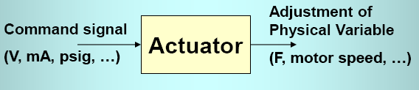
An actuator in its broadest definition is a device that produces linear or rotary motion from a source of power under the action of a source of control. Actuators take fluid, electric or some other source of power and convert it through a motor, piston or other device to perform work. Basic actuators are used to move valves to either fully opened or fully closed positions. Actuators for control or position regulating valves are given a positioning signal to move to any intermediate position with a high degree of accuracy. Although the most common and important use of an actuator is to open and close valves, current actuator designs go far beyond the basic open and close function. The valve actuator can be packaged together with position sensing equipment, torque sensing, motor protection, logic control, digital communication capacity and even PID control all in a compact environmentally protected enclosure.
As automation is adopted in more facilities, physical work is being replaced by machines and their automatic controls. The need for valve actuators to provide the interface between the control intelligence and the physical movement of a valve has grown. There is an important need for the increased working safety and the environmental protection that valve actuators can provide. Some areas are hazardous or hostile to human beings. In these circumstances an automated actuation device can reduce the risk to the individuals. Certain critical valves need to be opened or closed rapidly in the event of emergency circumstances. The valve actuator can prevent serious environmental catastrophes as well as minimize damage to facilities in such circumstances. With some processes requiring high pressures and large line sizes, the amount of power required to open or close a valve can be significant. In these circumstances the enhanced mechanical advantage and application of high output motors can facilitate easy operation of large valves.

Common Actuator Types

Manual Actuators
A manual actuator employs levers, gears, or wheels to facilitate movement while an automatic actuator has an external power source to provide the force and motion to operate a valve remotely or automatically. Power actuators are a necessity on valves in pipelines located in remote areas; they are also used on valves that are frequently operated or throttled. Valves that are particularly large may be impossible or impractical to operate manually simply because of the sheer horsepower requirements. Some valves may be located in extremely hostile or toxic environments that preclude manual operation. Additionally, as a safety feature, certain types of power actuators may be required to operate quickly, shutting down a valve in case of emergency.

Electric Actuators
The electric actuator has a motor drive that provides torque to operate a valve. Electric actuators are frequently used on multi-turn valves such as gate or globe valves. With the addition of a quarter-turn gearbox, they can be utilized on ball, plug, or other quarter-turn valves.
Electromagnetic Actuators
This exploits the mutual attraction of soft ferrous materials in a magnetic field. The device has one coil which provides the field energy and the energy to be transformed. The attractive force is unidirectional such that the return device of some type is needed, often a spring. Relays or solenoids are based on this principle which is widely used in cars to switch a range of electrical equipment with a current demand of more than about 10Amps – examples include in fans, head lights, horn, and wipers.
Electrodynamic Actuator
This is based on the (Lorenz) force generated when a current carrying conductor (often in the form of a coil) is held in a magnetic field. DC motors are frequently used as part of an actuator system.

Hydraulic and Pneumatic Actuators

Hydraulic and Pneumatic actuators are often simple devices with a minimum of mechanical parts, used on linear or quarter-turn valves. Sufficient air or fluid pressure acts on a piston to provide thrust in a linear motion for gate or globe valves. Alternatively, the thrust may be mechanically converted to rotary motion to operate a quarter-turn valve. Most types of fluid power actuators can be supplied with fail-safe features to close or open a valve under emergency circumstances. Key features of pneumatic and hydraulic systems are summarized below:
Features | Hydraulic Actuators | Pneumatic Actuators
Medium | Fluid is used and can be oil, oil/water mix (non flammable) or water + corrosion inhibitors  Virtually incompressible and viscosity is heavily dependent on temperature. | Usually Air. Compressible and separate lubrication probably required. Viscosity fluctuations not important
Pressure Range | Up to about 30MPa - 200MPa for diesel injectors | Up to about 1MPa
Applications | Positioning with high load rigidity and precision in closed loop control systems | Devices with lower power and force / torque requirements, positioning by mechanical stops in open loop systems.

Current Trends in Actuators
A significant trend is the move away from hydraulic to electrical devices. This is driven partly by the desire to have cleaner systems (no hydraulic fluid) and making integration with other (normally electrical) control systems easier to achieve. New cars are often now fitted with electric power assisted steering rather than the hydraulic system that was the only system available till recently. Developments are progressing with electrical assistance of car braking systems. This trend to electrical systems is also present in the aviation industry, but the very high power densities and forces required from some actuators mean that this will be more difficult.
Actuator Classification/Grouping
- Control Valve: Pneumatic, Electric, Hydraulic
- Electric Heater Output: SCR, Thyristor
- Pump/Motor Speed: Inverter
- Displacement: Pneumatic, Electric, Hydraulic

Industrial Actuators

Industrial actuators convert the industrial standard signal to action such as valve opening, power level, displacement and etc. Standard instrumentation signal levels and signal conversion transmitters are used. We will look at Process Control Valves in more detail later.

Solenoid Actuators

Solenoids are the most common actuator components. The basic principle of operation is that, there is a moving ferrous core (a piston) that will move inside wire coil as shown in Figure 11.69. Normally the piston is held outside the coil by a spring. When a voltage is applied to the coil and current flows, the coil builds up a magnetic field that attracts the piston and pulls it into the center of the coil. The piston can be used to supply a linear force. Well known applications of these include in pneumatic values and car door openers.
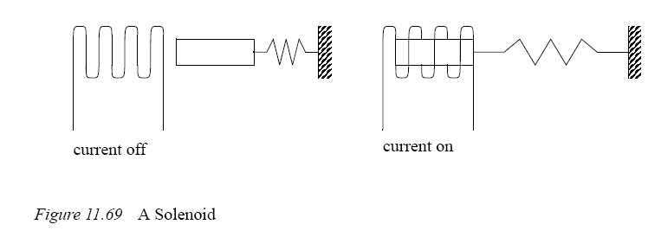
As mentioned before, inductive devices can create voltage spikes and may need snubbers, although most industrial applications have low enough voltage and current ratings they can be connected directly to the PLC outputs. Most industrial solenoids will be powered by 24Vdc and draw a few hundred mA.

Piston and Cylinder Actuators

A cylinder uses pressurized fluid or air to create a linear force/motion as shown in Figure 11.72. In the figure a fluid is pumped into one side of the cylinder under pressure causing that side of the cylinder to expand, and advancing the piston. The fluid on the other side of the piston must be allowed to escape freely - if the incompressible fluid was trapped the cylinder could not advance. The force the cylinder can exert is proportional to the cross sectional area of the cylinder.
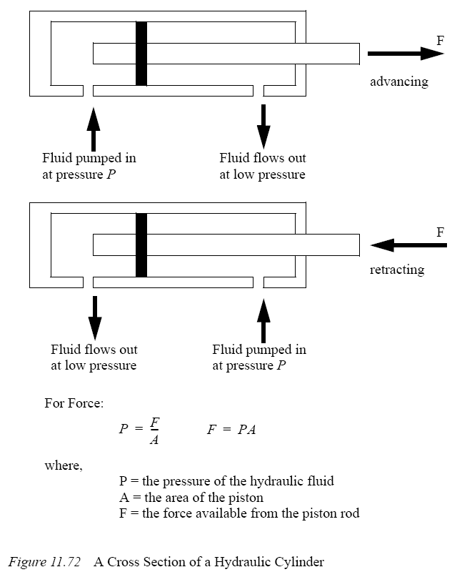
Single acting cylinders apply force when extending and typically use a spring to retract the cylinder. Double acting cylinders apply force in both directions.

