Industrial Temperature Sensors

In this section the subject of temperature measurement will be covered more broadly. There are a wide variety of sensors and transducers available for measuring pressure, level, humidity, and other physical properties. The sensor is the part of process control system, which experiences the change in the controlled variable. The sensor may be of a type where a change in temperature results in a change of voltage or perhaps a change in resistance. The signal from the sensor may be very small, creating the need for local signal conditioning and amplification to read it effectively. A small change in resistance signalled by a sensor in response to a change in temperature, may, for example, be converted to an electrical voltage or current for onward transmission to the controller.
The transmission system itself is a potential source of error. Wiring incurs electrical resistance (measured in ohms), as well as being subject to electrical interference (noise). In a comparable pneumatic system, there may also be minute leaks in the piping system. The term 'thermostat' is generally used to describe a temperature sensor with on/off switching. 'Transducer' is another common term, and refers to a device that converts one physical characteristic into another; for example, temperature into voltage (millivolts). An example of a transducer is a device that converts a change in temperature to a change in electrical resistance.
With pneumatic devices, the word 'transmitter' is frequently encountered. It is simply another description of transducer or sensor, but usually with some additional signal conditioning.
However, the actual measuring device is usually termed as the sensor, and the more common types will be outlined in the following Section.

Signals produced by sensor measurement and transducer transmission are processed by the process control system. They may be displayed on control panels as indicators, stored by recorders, or used by alarms or switches. Standard symbols for these devices consist of two letter groups -- the first indicates the process variable, the second the control function. So:
- PI - pressure indicator
- TC - temperature controller
- LAH - level alarm high
- FS - flow switch
- PRC - pressure recorder/controller
- TIC - temperature indicator/controller and so on.
A sensor device which provides local readout only is usually referred to as a gage. Local pressure gages and level gages (sight glasses) are very common. For process control system, repeatability is the most critical more than accuracy. The users of a transmitter must periodically calibrate the device. This is done by using the sensor to measure some fixed standard and adjusting its settings to ensure accuracy and repeatability. Users of a sensor/trasmitter typically specify three values:
- The zero is the measurement value corresponding to minimum signal (20 C set to produce 4 mA)
- The range specifies the boundaries of an operating region. This term is used loosely and so it is important to distinguish between
  - the instrument range which is characteristic of the device and set by tolerances, materials of construction, etc. (0 to 500 C can be seen without mechanical failure)
  - the operating range or calibrated range which the device is set to detect (for example, 20 C to 200 C)
- The span is the size of the calibrated operating region (180 C)
Most transmitters have set screws or other means of adjusting the zero and span; this is done during the calibration process to obtain a desired operating range.

Filled System Sensors

With pneumatic controllers, filled system sensors are employed. Figure 6.7.4 illustrates the principles of such a system.

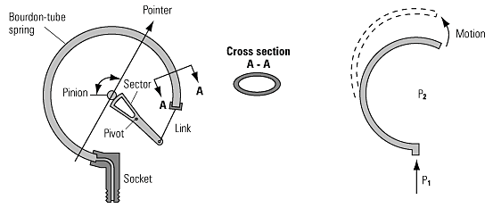
Fig. 6.7.4 Liquid filled system sensor and gas filled or vapour pressure system

When the temperature changes, the fluid expands or contracts, causing the Bourdon tube to tend to straighten out. Sometimes a bellows is used instead of a Bourdon tube. In the past, the filling has often been mercury. When heated, it expands, causing the Bourdon tube to uncoil; cooling causes contraction and forces the Bourdon tube to coil more tightly. This coil movement is used to operate levers within the pneumatic controller enabling it to perform its task. A pressure sensing version will simply utilise a pressure pipe connected to the Bourdon tube. Note: for health and safety reasons, mercury is now used less often. Instead, an inert gas such as nitrogen is often employed.

Resistance Temperature Detectors (RTDs)

Resistance Temperature Detectors (RTDs) as shown in figure 6.7.5 below employ the fact that the electrical resistance of certain metals change as the temperature alters. They act as electrical transducers, converting temperature changes to changes in electrical resistance. Platinum, copper, and nickel are three metals that meet RTD requirements and figure 6.7.6 shows the relationship between resistance and temperature.
A resistance temperature detector is specified in terms of its resistance at 0°C and the change in resistance from 0°C to 100°C. The most widely used RTD for the typical applications covered here are platinum RTDs. These are constructed with a resistance of 100 ohms at 0°C and are often referred to as Pt100 sensors. They can be used over a temperature range of -200°C to +800°C with high accuracy (± 0.5%) between 0°C and 100°C.
An RTD (Resistance Temperature Detector) is basically a temperature sensitive resistor. It is a positive temperature coefficient device, which means that the resistance increases with temperature. The resistance of the metal increases with temperature. The resistive property of the metal is called its resistivity. The resistive property defines length and cross sectional area required to fabricate an RTD of a given value. The resistance is proportional to length and inversely proportional to the cross sectional area:
r X L
R = ------------
A
Where
R = Resistance (ohms)
r = Resistivity (ohms)
L = Length
A = Cross sectional area

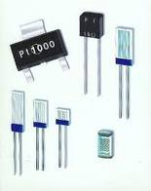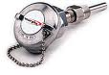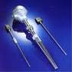
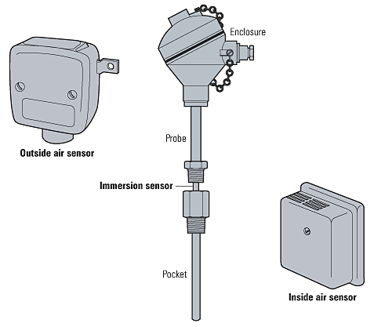
Fig. 6.7.5 Typical Resistance Temperature Sensors

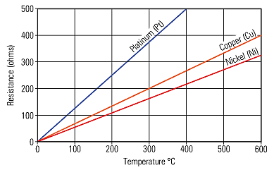
Fig. 6.7.6 RTD element typical resistance/temperature graphs

As can be seen from Figure 6.7.6, the increase of resistance with temperature is virtually linear. RTDs have a relatively small change in resistance, which requires careful measurement. Resistance in the connecting cables needs to be properly compensated for.

RTD Materials

The criterion for selecting a material to make an RTD is:
- The material must be malleable so that it can be formed into small wires
- It must have a repeatable and stable slope or curve
- The material should also be resistant to corrosion
- The material should be low cost
- It is preferred that the material have a linear resistance verses temperature slope

Platinum with a temperature coefficient of 0.00385 - 0.003923 W/W/°C and practical temperature range of -452 to +1100°F (-269 to +593°C). The platinum RTD has the best accuracy and stability among the common RTD materials. The resistance versus temperature curve is fairly linear and the temperature range is the widest of the common RTD materials.

Thermistors

Thermistors use semi-conductor materials, which have a large change in resistance with increasing temperature, but are non-linear. The resistance decreases in response to rising temperatures (negative coefficient thermistor), as shown in Figure 6.7.7.
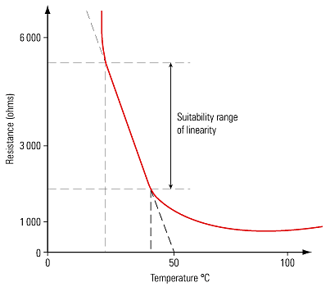
Fig. 6.7.7 Negative Coefficient Thermistor

Positive coefficient thermistors can be manufactured where the resistance increases with rising temperature (Figure 6.7.8) but their response curve makes them generally unsuitable for temperature sensing. Thermistors are less complex and less expensive than RTDs but do not have the same high accuracy and repeatability. Their high resistance means that the resistance of the connecting cable is less important.
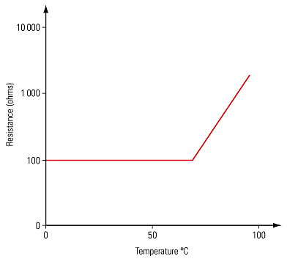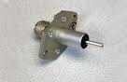
Fig. 6.7.8 Positive coefficient thermistor

Thermocouples

If two dissimilar metals are joined at two points and heat is applied to one junction (as shown in Figure 6.7.9), an electric current will flow around the circuit. Thermocouples produce a voltage corresponding to the temperature difference between the measuring junction (hot) and the reference junction (cold).
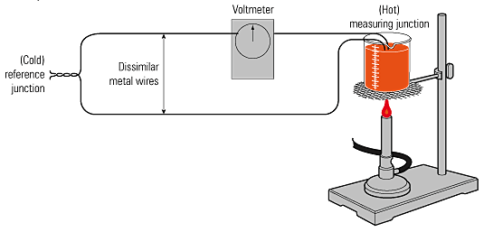
Fig. 6.7.9 Thermocouple connection

The cold reference junction temperature must be accurately known if the thermocouple itself is to provide accurate sensing. Traditionally, the cold junction was immersed in melting ice (0°C), but the temperature of the cold junction is now measured by a thermistor or an RTD and, from this, the indicated temperature, generally at the measuring junction, is corrected. This is known as cold junction compensation.
Any pair of dissimilar metals could be used to make a thermocouple. But over the years, a number of standard types have evolved which have a documented voltage and temperature relationship. The standard types are referred to by the use of letters, that is, Type J, K, T and others.
Table 6.7.1 Standard range of thermocouples and their range (°C)
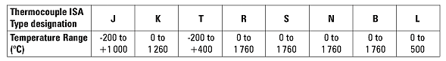

The most widely used general-purpose thermocouple is Type K. The dissimilar metals used in this type are Chrome (90% nickel, 10% chromium) and Alumel (94% nickel, 3% manganese, 2% Aluminium and 1% silicon) and can be used between the range 0°C to 1 260°C. Figure 6.7.10 illustrates the sensitivity of Type K thermocouples, and it can be seen that the output voltage is linear across the complete range.
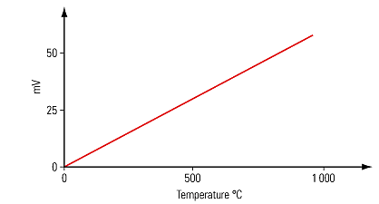
Fig. 6.7.10 Sensitivity of Type K thermocouple

Extension tail wires are used to connect the measuring junction to the reference junction in the instrument case. These extension tails may be of the same material as the wires in the thermocouple itself, or may be a compensating cable made of copper and copper-nickel alloy. Both extension tails must be of the same material.
Thermocouples are available in a wide variety of sizes and shapes. They are inexpensive and rugged and reasonably accurate, with wide temperature ranges. However, the reference junction temperature must be held at a constant value otherwise deviations must be compensated for. The low junction voltages mean that special screened cable and careful installation must be used to prevent electrical interference or 'noise' from distorting signals.

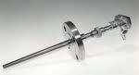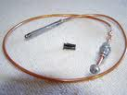

Sensor Transfer Function

The Sensor Transfer function is given by:

Where,

S = output signal;

s = stimulus; and

f(s) = functional relationship

For binary sensors:

S = 1 if s > 0 and

S = 0 if s < 0.

The ideal functional form for an analogue measuring device is a simple proportional relationship, such as:

Where,

C = output value at a stimulus value of zero and m = constant of proportionality (sensitivity)

Example

The output voltage of a particular thermocouple sensor is registered to be 42.3mV at temperature 105°C. It had previously been set to emit a zero voltage at 0°C. Since an output/input relationship exists between the two temperatures, determine:
(1) The transfer function of the thermocouple, and
(2) The temperature corresponding to a voltage output of 15.8 mV.

Solution
42.3 mV = 0 + m(105°C) = m(105°C)
or m = 0.4028571429
S = 0.4 (s)
15.8 mV = 0.4 (s)
15.8 / 0.4 = s
s = 39.22°C

