Non-Linear Process Control Systems

Below is figure 1 showing a typical application of a block diagram to identify the operation of a temperature control system for lubricating oil. (A) in Figure 1 shows a schematic diagram of the lube oil cooler and its associated temperature control system.

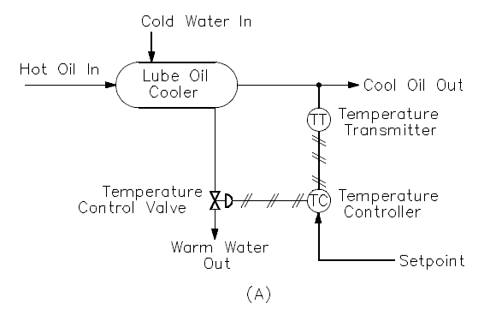
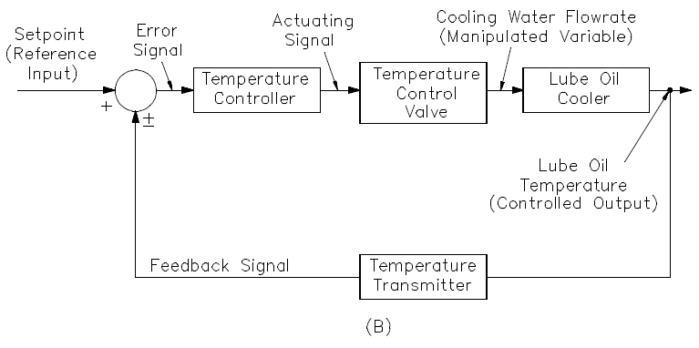
Figure 1: Oil Lubrication System
Lubricating oil reduces friction between moving mechanical parts and also removes heat from the components. As a result, the oil becomes hot. This heat is removed from the lube oil by a cooler to prevent both breakdown of the oil and damage to the mechanical components it serves.
The lube oil cooler consists of a hollow shell with several tubes running through it. Cooling water flows inside the shell of the cooler and around the outside of the tubes. Lube oil flows inside the tubes. The water and lube oil never make physical contact.

As the water flows through the shell side of the cooler, it picks up heat from the lube oil through the tubes. This cools the lube oil and warms the cooling water as it leaves the cooler. The lube oil must be maintained within a specific operating band to ensure optimum equipment performance. This is accomplished by controlling the flow rate of the cooling water with a temperature control loop. The temperature control loop consists of a temperature transmitter, a temperature controller, and a temperature control valve. The diagonally crossed lines indicate that the control signals are air (pneumatic).

In figure (B) in Figure 1 represents the lube oil temperature control loop in block diagram form. The lube oil cooler is the plant in this example, and its controlled output is the lube oil temperature. The temperature transmitter is the feedback element. It senses the controlled output and lube oil temperature and produces the feedback signal. The feedback signal is sent to the summing point to be algebraically added to the reference input (the setpoint). Notice the setpoint signal is positive, and the feedback signal is negative. This means the resulting actuating signal is the difference between the setpoint and feedback signals.

In the oil lube example, the control of the lube oil temperature may initially seem easy. Apparently, the operator need only measure the lube oil temperature, compare the actual temperature to the desired (setpoint), compute the amount of error (if any), and adjust the temperature control valve to correct the error accordingly. However, processes have the characteristic of delaying and retarding changes in the values of the process variables. This characteristic greatly increases the difficulty of process control.

Process Variability / Process Time Lags

To deliver acceptable returns to shareholders, international industry leaders are realizing they must reduce raw material and scrap costs while increasing productivity. Reducing process variability in the manufacturing/industrial processes through the application of process control technology is recognized as an effective method to improve financial returns and meet global competitive pressures.

The basic objective of a company is to make a profit through the production of a quality product. A quality product conforms to a set of specifications. Any deviation from the established specification means lost profit due to excessive material use, reprocessing costs, or wasted product. Thus, a large financial impact is obtained through improving process control. Reducing process variability through better process control allows optimization of the process and the production of products right the first time.

Process time lags is the general term that describes these process delays and retardations.

Process time lags are caused by three properties of the process namely:
- Capacitance,
- Resistance, and
- Transportation time.

Capacitance

This is the ability of a process to store energy. In figure 1, for example, the walls of the tubes in the lube oil cooler, the cooling water, and the lube oil can store heat energy. This energy-storing property gives the ability to retard change. If the cooling water flow rate is increased, it will take a period of time for more energy to be removed from the lube oil to reduce its temperature.

Resistance

This is that part of the process that opposes the transfer of energy between capacities. In figure 1, the walls of the lube oil cooler oppose the transfer of heat from the lube oil inside the tubes to the cooling water outside the tubes.

Transportation Time

This is time required to carry a change in a process variable from one point to another in the process. If the temperature of the lube oil (Figure 1) is lowered by increasing the cooling water flow rate, some time will elapse before the lube oil travels from the lube oil cooler to the temperature transmitter. If the transmitter is moved farther from the lube oil cooler, the transportation time will increase. This time lag is not just a slowing down or retardation of a change; it is an actual time delay during which no change occurs. Other Types of Process Control Delays/Lags include:

Hysteresis

Hysteresis occurs when the same change in the controller output in both directions results in a different change in the process value. For example, when the controller output is 20%, the process variable is 30°C. When the controller output increases to 25%, the temperature increases to 35°C. However, when the controller goes back down to 20%, the temperature only goes down to 33°C. This results in different process gains in both directions and will confuse the controller, which has been tuned for only one process gain. We have to remember that industrial controllers are linear.
Hysteresis happens in a valve with loose linkages, the air signal to the valve will have to change by an amount equal to the hysteresis before the valve stem will move. Once the valve has begun to move in one direction it will continue to move if the air signal keeps moving in the same direction. When the air signal reverses direction, the valve will not move until the air signal has changed in the new direction by an amount equal to the hysteresis.

Plant Smoke/Home Smoke Alarms
A smoke detector is also an example of hysteresis, not deadband. The smoke detector at the ceiling of the plant or kitchen starts the alarm as soon as the level of smoke reaches a certain starting value, x, then the smoke detector stays in the alarm position until the level of smoke has been reduced to level y, after which the smoke detector is reset automatically to "normal". The hysteresis here is x minus y.
Deadband

Dead band is a major contributor to excess process variability, and control valve assemblies can be a primary source of dead band in an instrumentation loop due to a variety of causes such as friction, backlash, shaft windup, relay or spool valve dead zone, etc..
Deadband (sometimes called a neutral zone) is an area of a signal range or band where no action occurs (the system is dead). Deadband is used in voltage regulators and other controllers. The purpose is common; to prevent oscillation or repeated activation-deactivation cycles (called 'hunting' in proportional control systems).
Deadband is a general phenomenon where a range or band of controller output values fails to produce a change in the measured process variable. This is bad for process control. Process control systems these days execute at a rate of about 3 times per second. On top of that, each time it executes the output changes in the magnitude of usually less than 1%. But most relevant in the case of deadband, the changes can occur is either direction.
If a control valve is suffering from a deadband problem, when the controller output reverses direction, the control valve does not respond. Therefore the process variable also does not respond to the command of the controller. The controller does not know it, it thinks that its previous command is not good enough and so issues another (sometimes more drastic) command. When the control valve finally comes out of its deadband, the controller command has caused it to overshoot. The controller then tries to go back the other direction only to be faced with the same situation. And the process will be driven to overshoot in both directions and cycles continuously forming what is called a limit cycle.

Stiction

This is somewhat similar to deadband except that it does not only happen when the controller changes direction. Again stiction (also known as 'sticky valve') can be due to a variety of reasons, a common one which is packing friction. As far as process control is concerned, the effect of stiction is also like deadband whereby the valve fails to respond when required and when it does respond, overshoots the setpoint. The controller then tries to bring it back the other way.

